Lab6 prelab

James Stallkamp

1 Polling VS interrupts.

Polling is the process where a protocol is run to cause the CPU to regularly communicate with devices and check for a “command ready” bit or if information should be processed. Polling is ideally used in situations where events take place at regular intervals. Examples where polling works well are displays like and LCD panel or a mouse input.

An Interrupt is a hardware mechanism that can send a signal to the CPU indicating that a device needs attention. Interrupts are generally used for events that take place randomly or not at regular intervals. Examples where interrupts work well are sensor inputs like motion sensors or buttons.

2 EICRA and EICRB are registers that control the behavior of interrupts. Every two bits in each register corresponds to an interrupt, the different combinations of these bits correspond to different settings for the interrupt, EICRA controls interrupts 0-3 and EICRB controls 4-7. IE bits 0 and 1 in EICRA control settings for interrupt 0 and so forth. The combinations of these two bit controls are 00 for low level, 01 for falling edge, 11 for rising edge, and 01 for any level. Any level only works on interrupts 4-7.

EIMSK: The external interrupt mask register is used to control which interrupts are detected or ignored. Each bit corresponds to an interrupt, IE setting bit 0 in the the EMISK register to a 1 makes it so that the CPU will listen for interrupts from interrupt 0.

3 An interrupt vector is an identifier used to redirect the flow of the program, it causes the processor to fetch and execute the instructions at specified by the vector.

Timer0/Counter0 Overflow: $0020

External interrupt 5: $0005

Analog comparator: $002e

4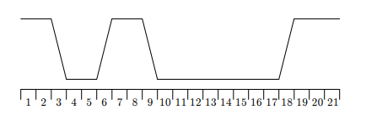

A)Rising:5-6 & 17-18

B)Falling:2-3 & 8-9

C)Low: 3-5 & 9-17

D)High:1-2 & 6-8, & 18-21